**BUG001 – Profile Picture Deletion Not Persisting**

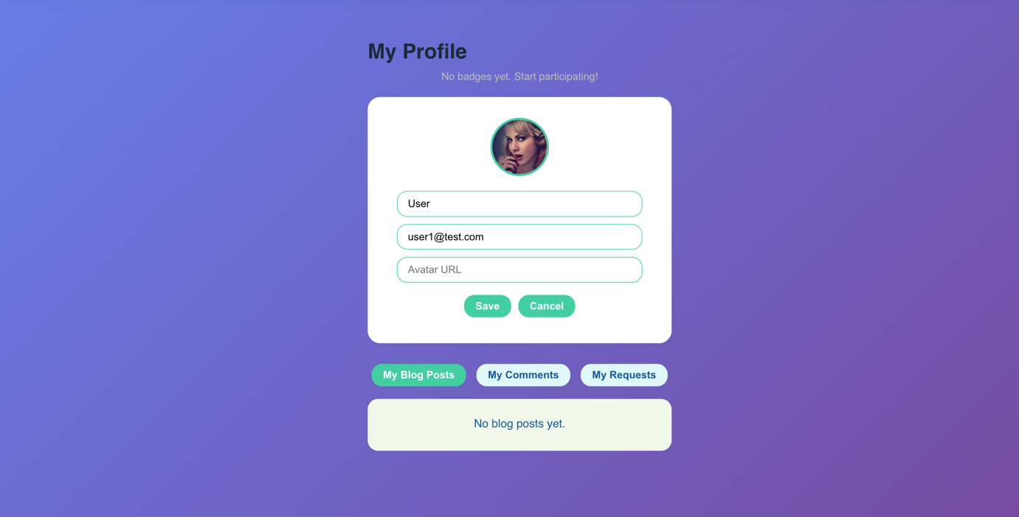

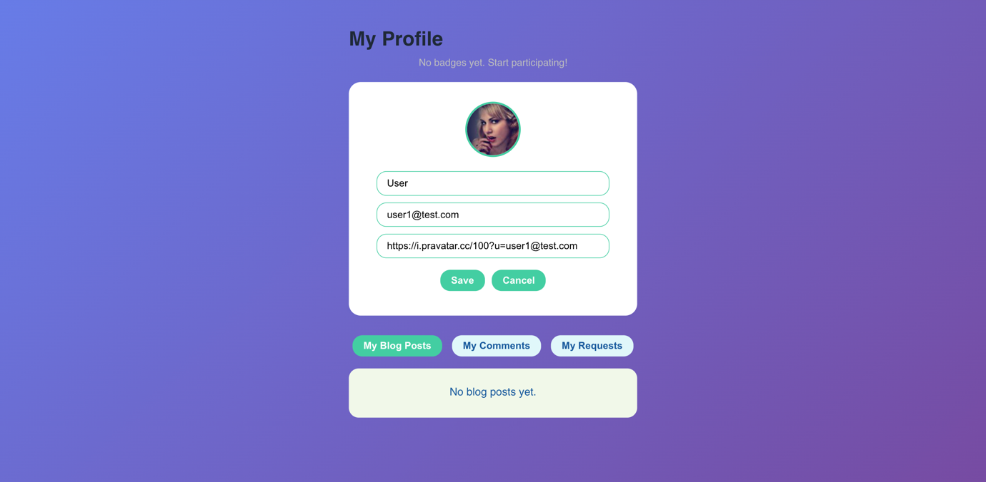

**BUG002 – Quiz Does Not End After Final Question**

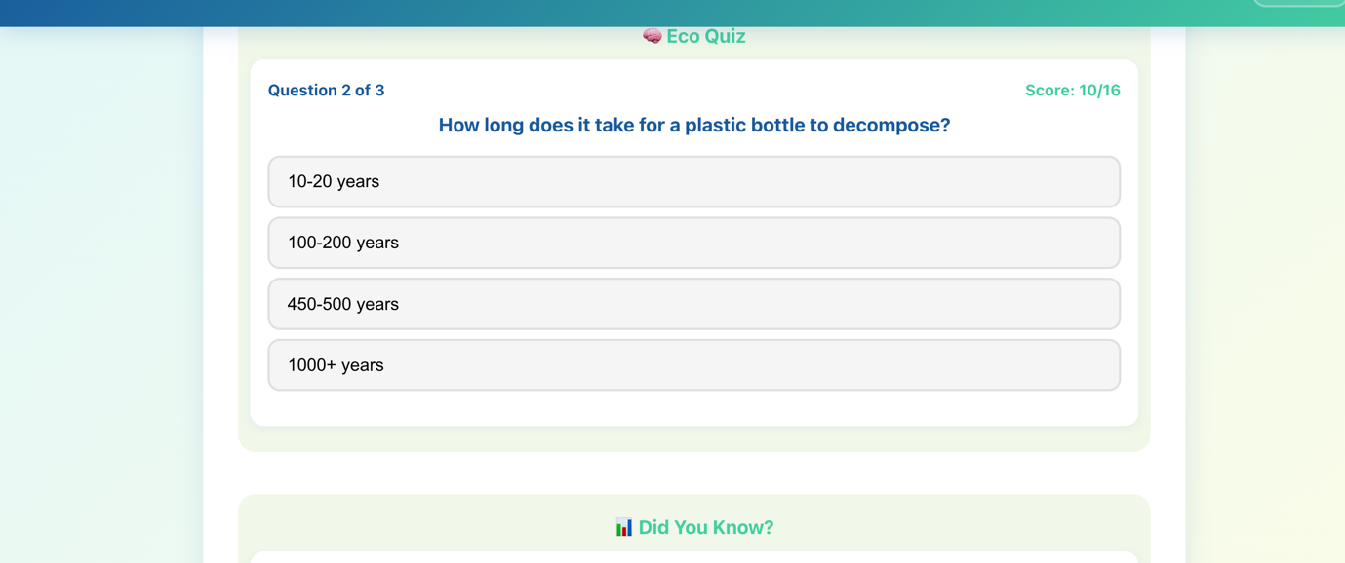

**BUG003 – Unauthorized Login Without Registered Account**

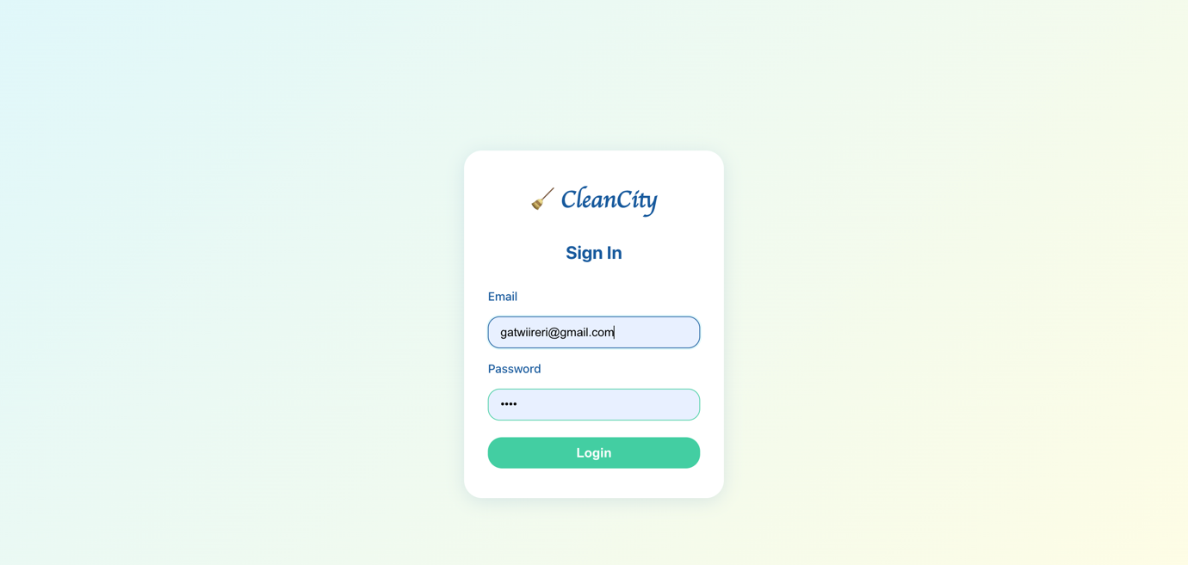

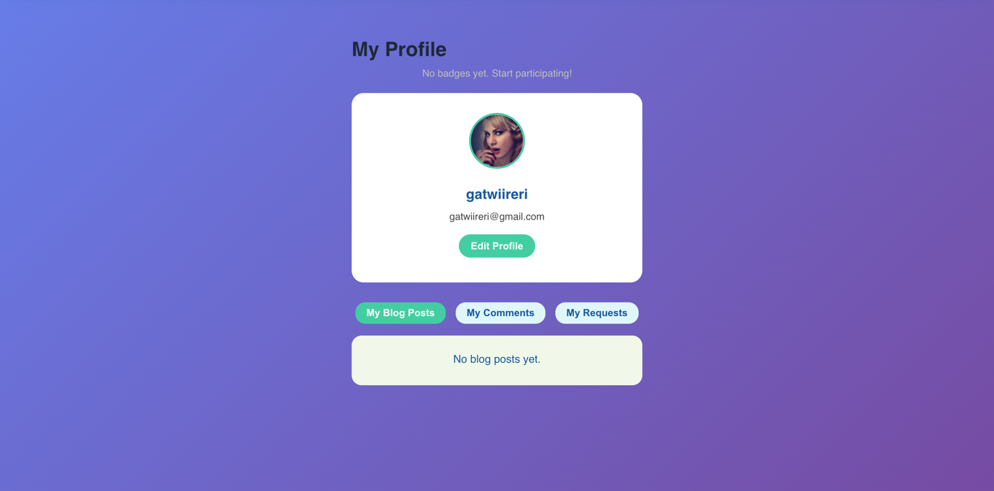

**BUG004 – System Accepts Past Dates for Waste Pickup Scheduling**

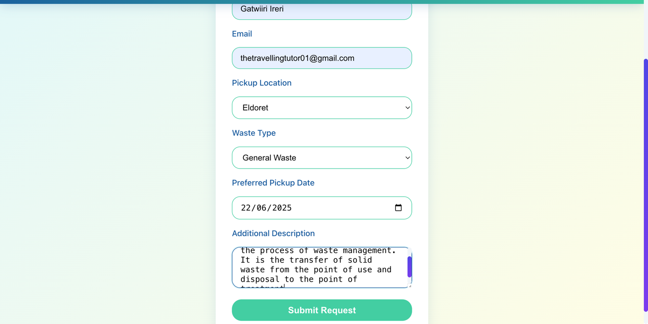

**BUG005 – Missing Hamburger Menu Icon for Mobile Navigation**

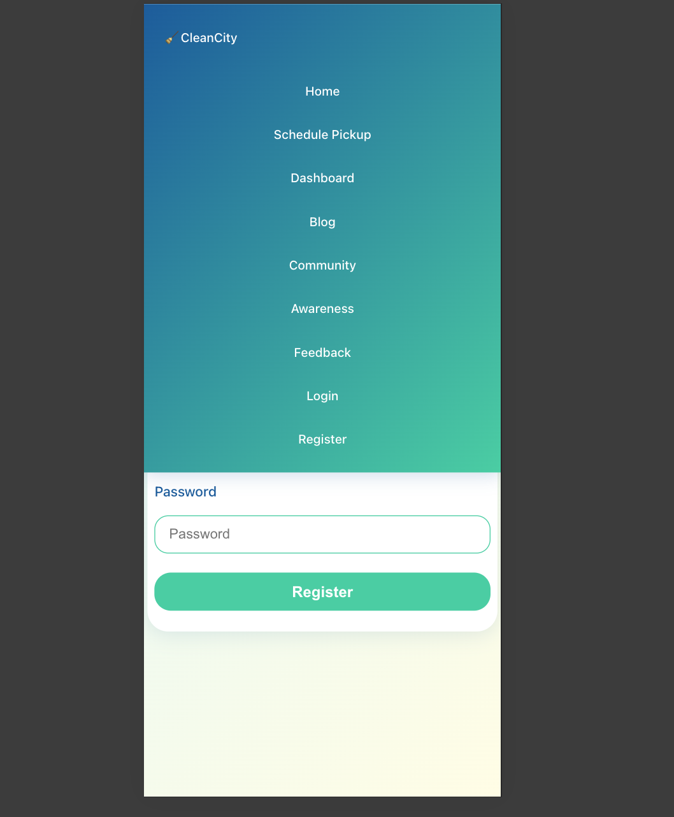

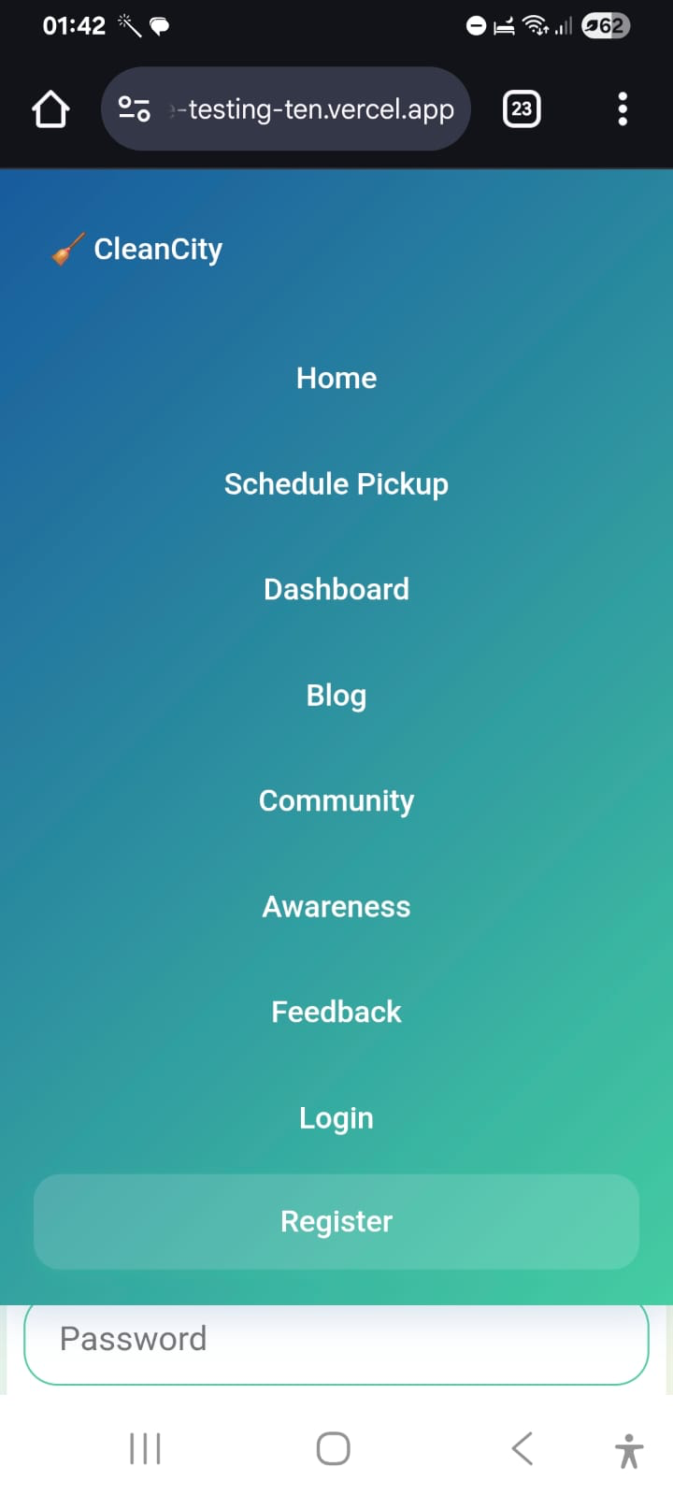

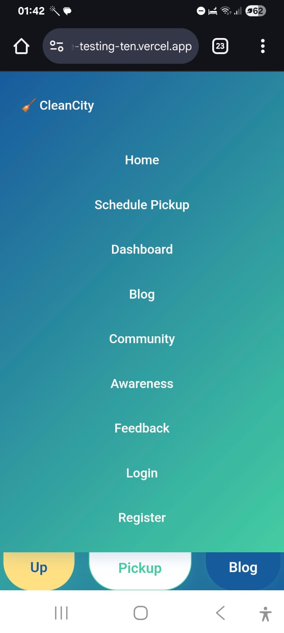

**BUG006 – Dashboard Not Updating Total Requests After Submission**

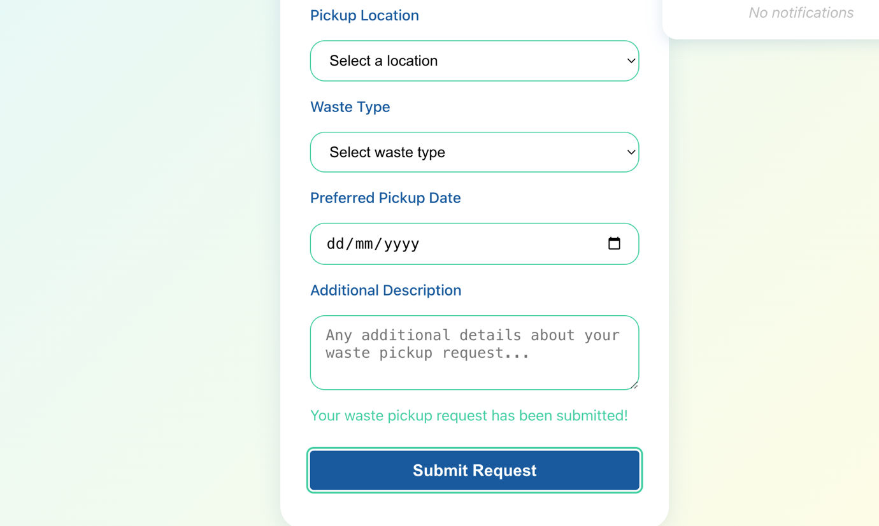

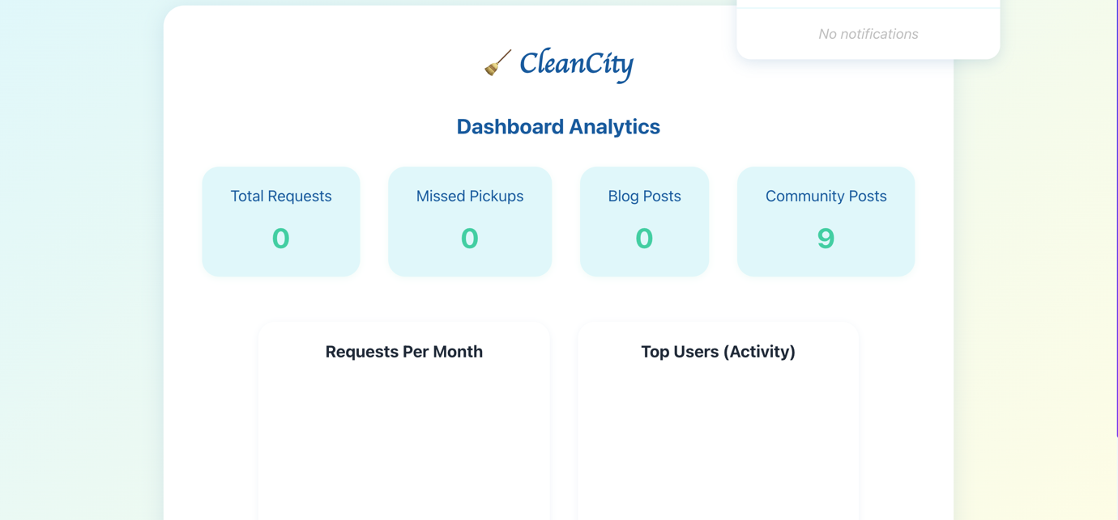

**BUG007 – Incorrect Location Filter Returns Wrong Data for Eldoret**

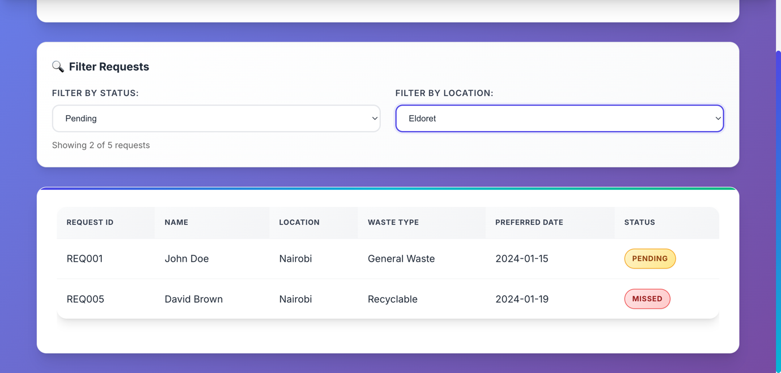

**BUG008 – Status Filter Not Working Correctly in Admin Dashboard**

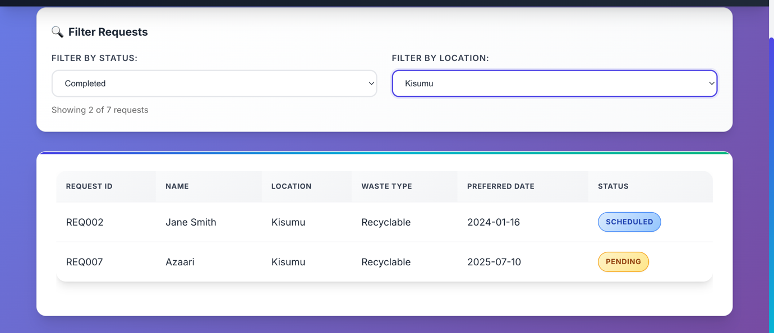

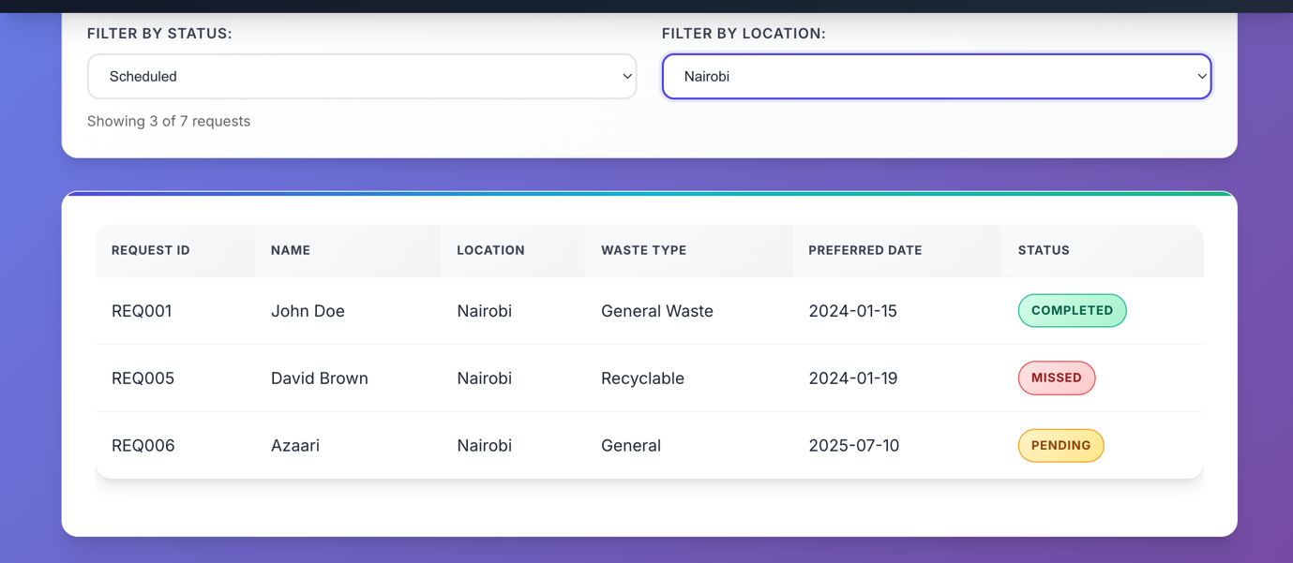

**BUG-009 – Edit button is non-functional - does not open edit interface when clicked**

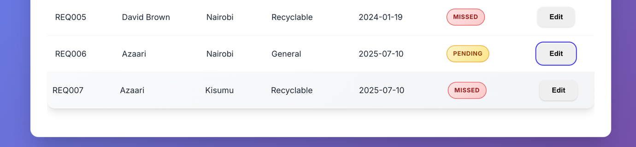

**BUG010 – Navigation Menu Layout Broken on Mobile Devices**

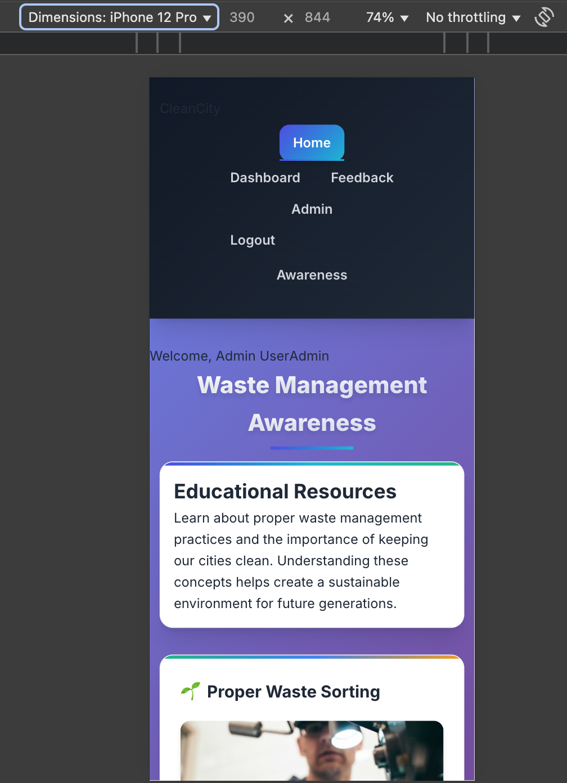

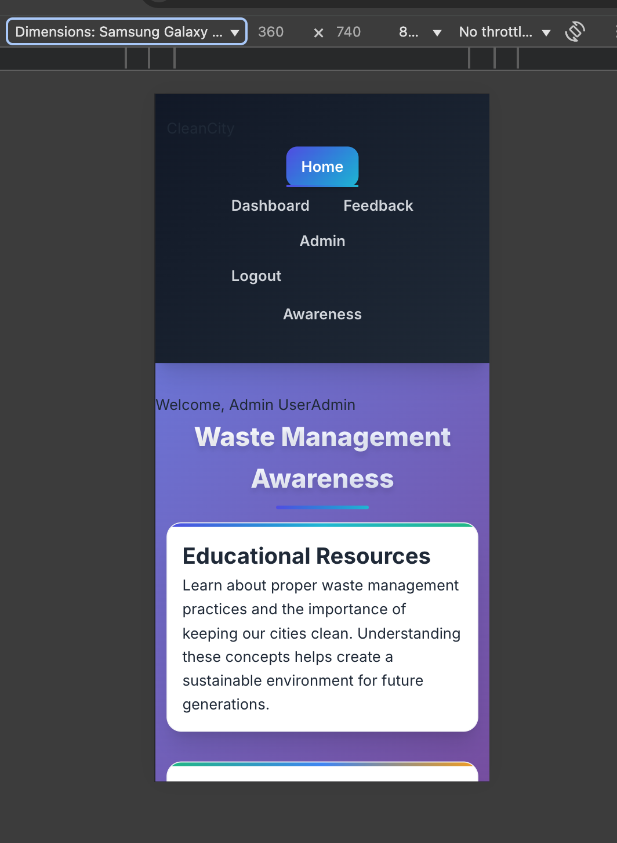

**BUG011 – Form Accessibility Issues Affecting Performance Score**

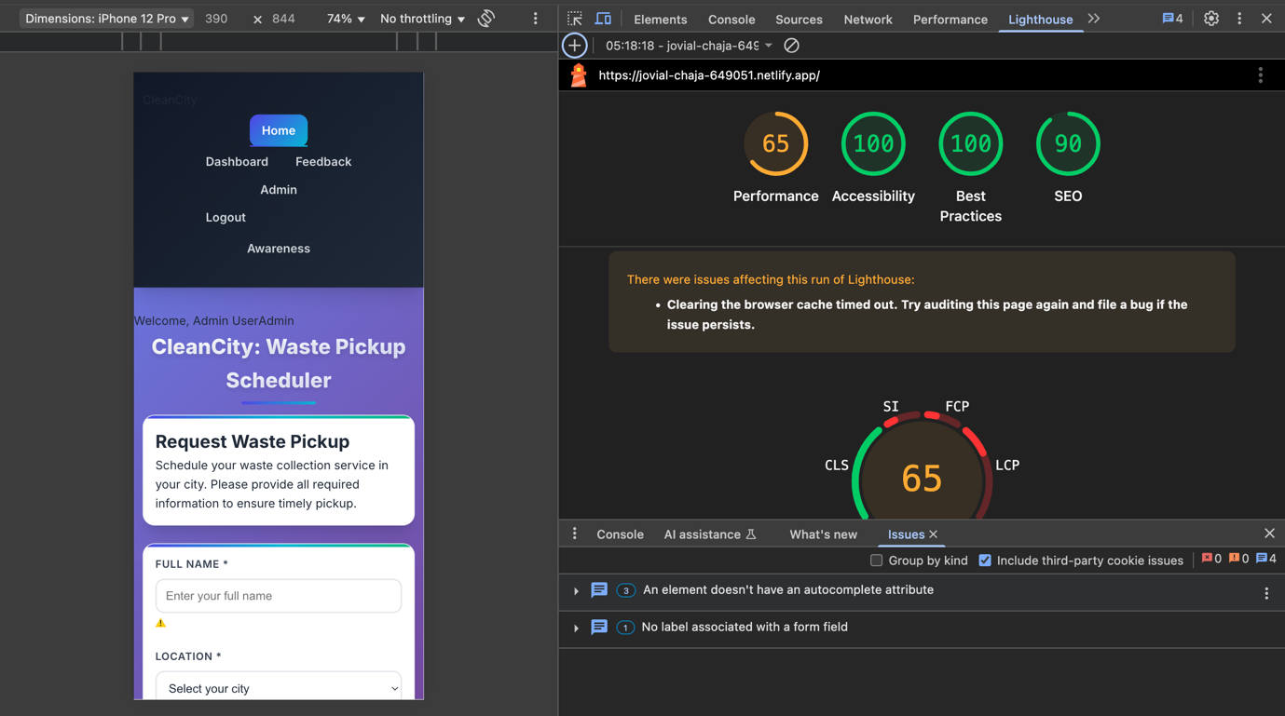

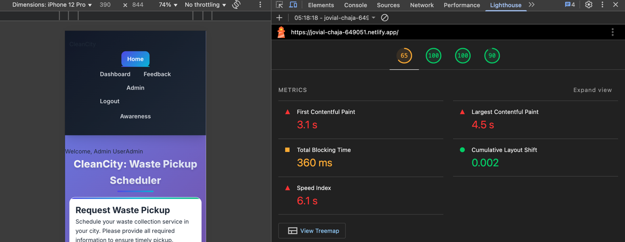

**BUG012 – Keyboard Accessibility Missing Causing Performance Degradation**

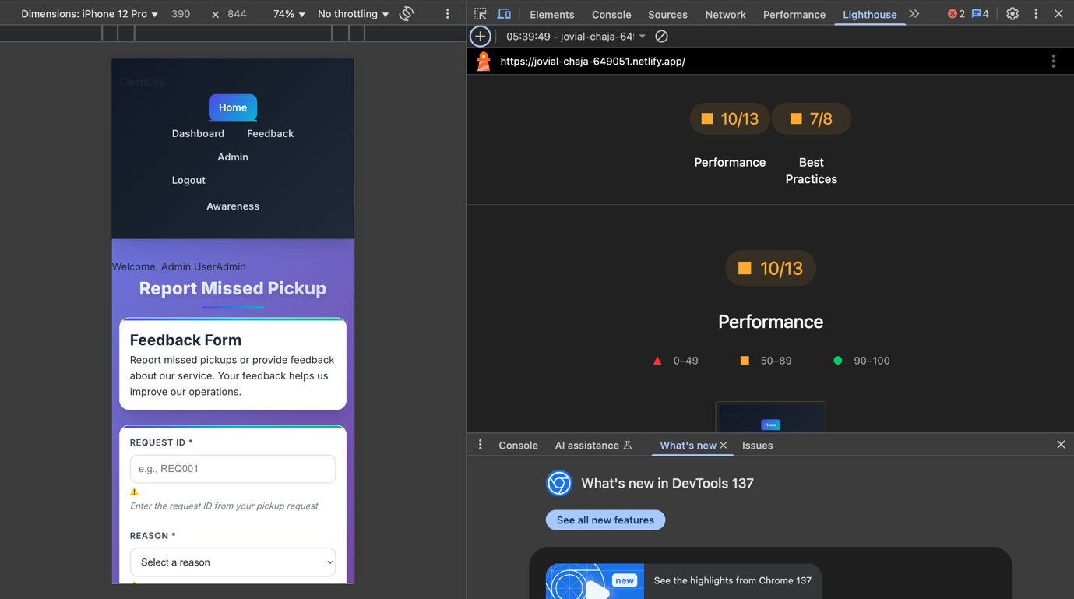

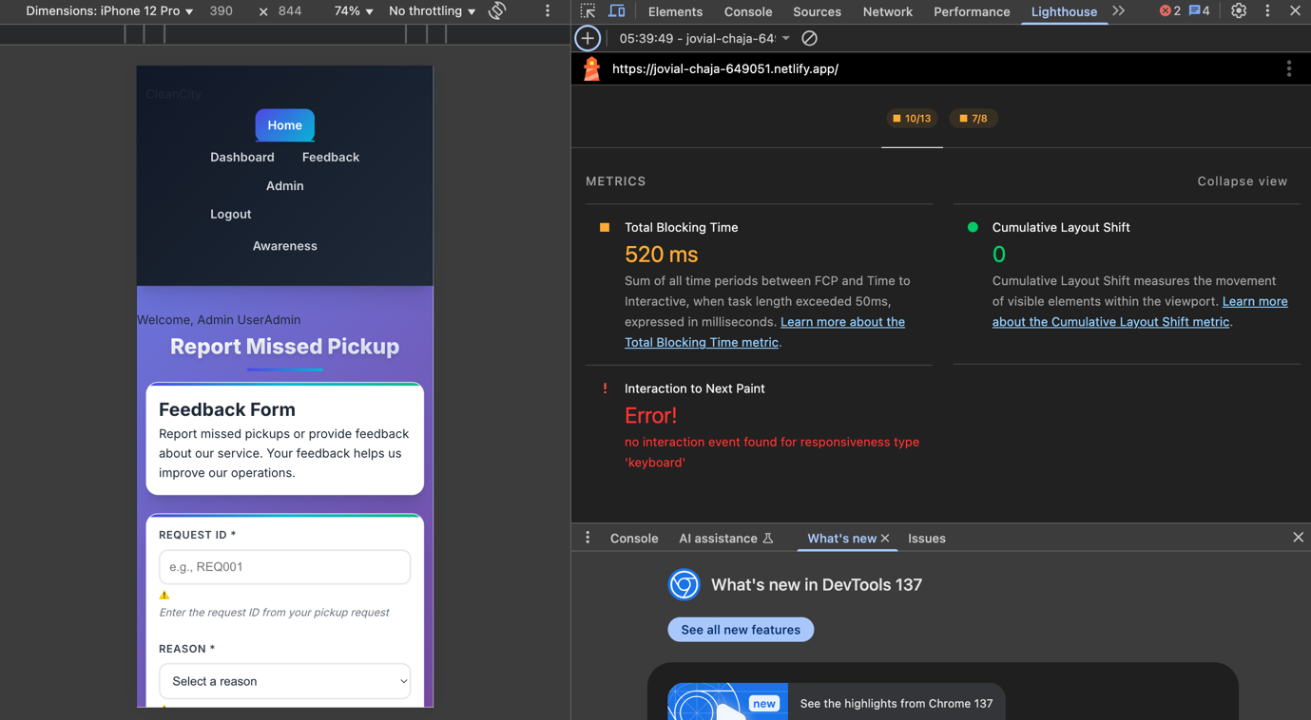

**BUG013 – CleanCity Logo/Brand Text Visibility Issue**

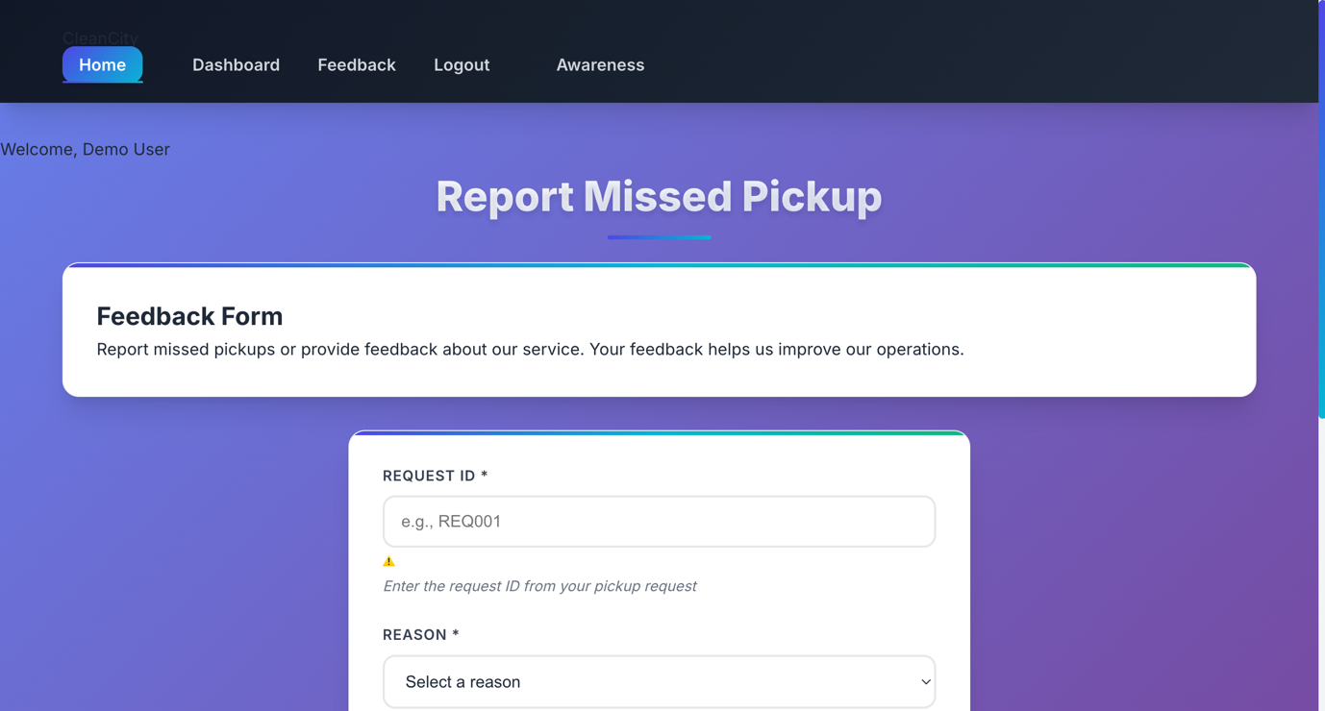

**BUG014 – Comments Not Persisting After Page Refresh**

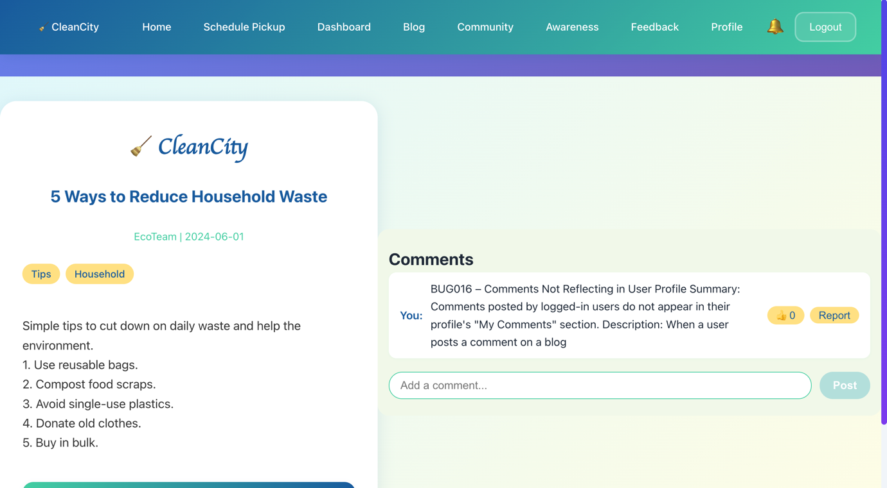

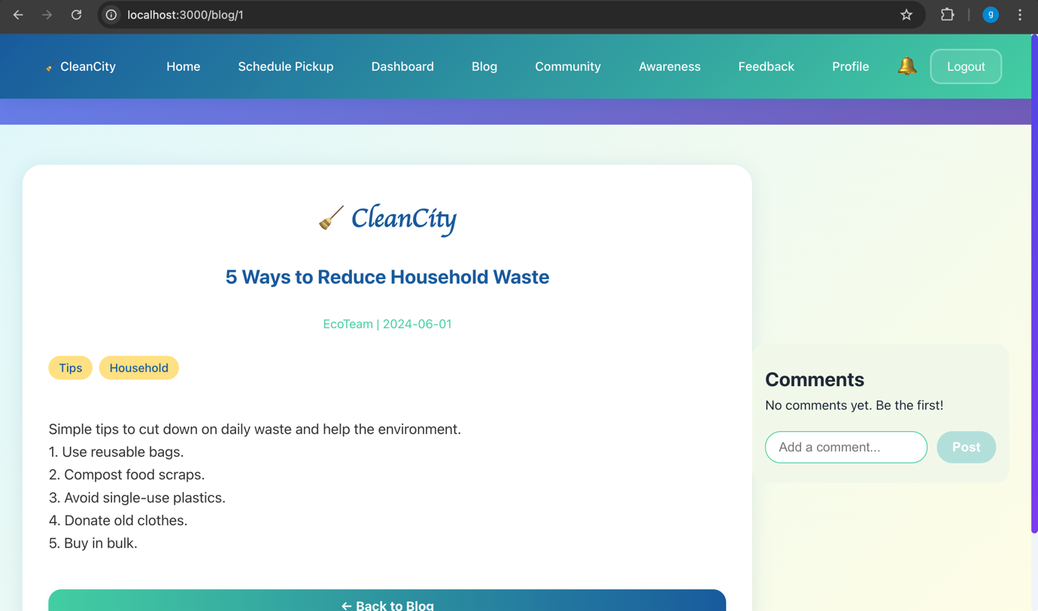

**BUG015 – Blog Page Navigation Menu Unresponsive on Mobile Devices**

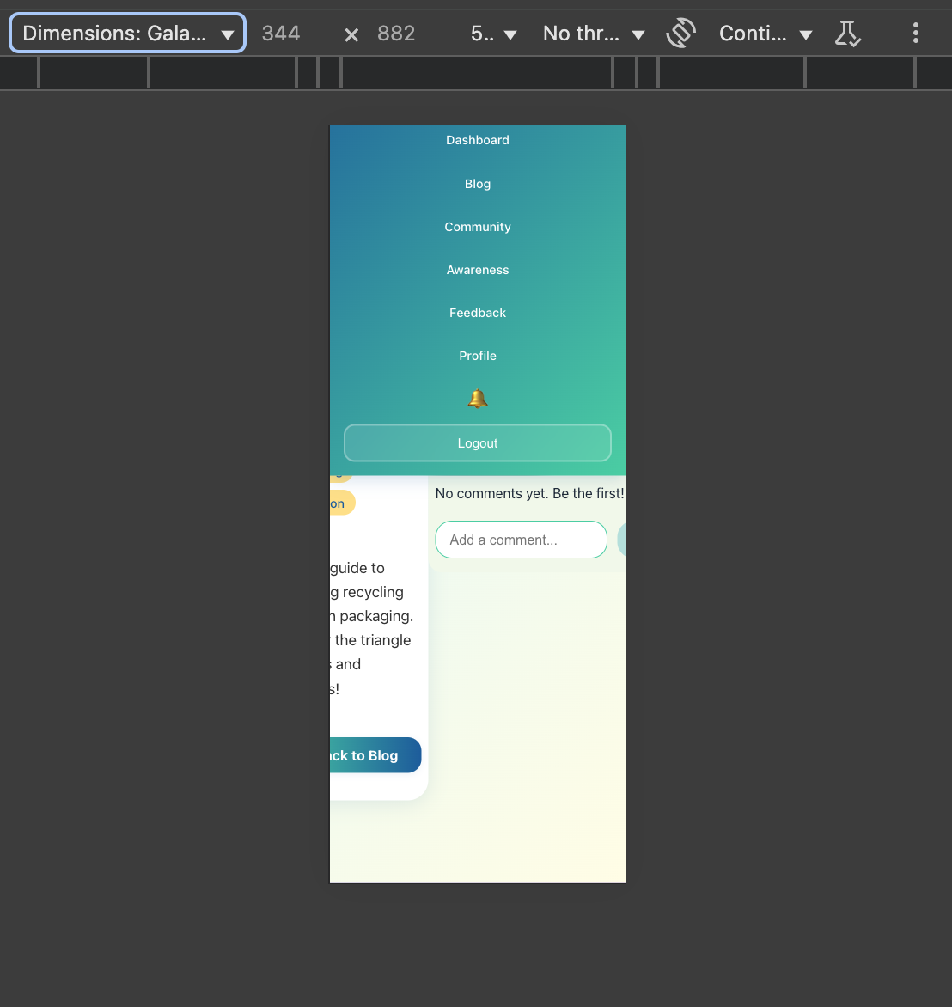

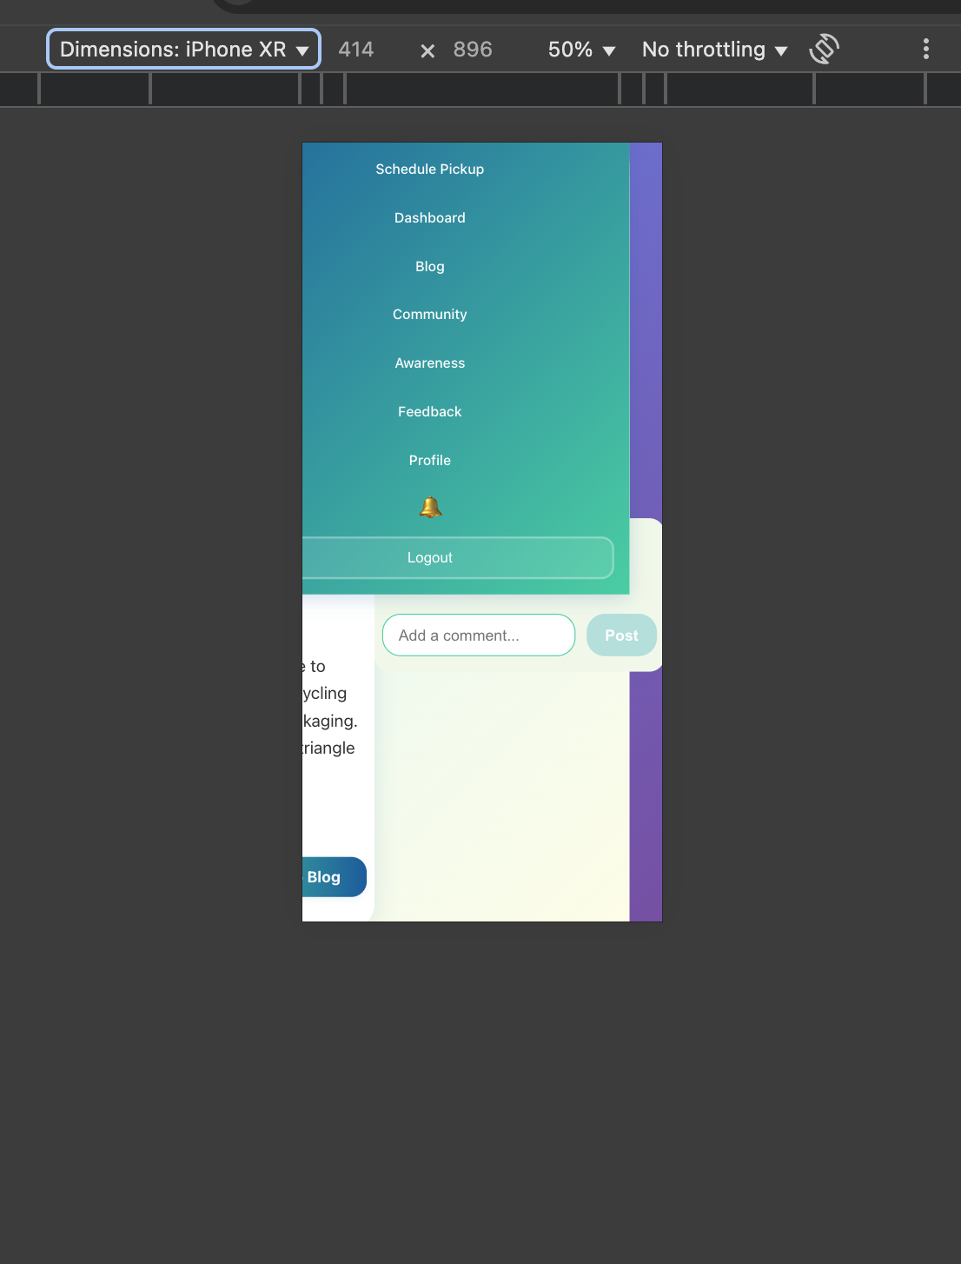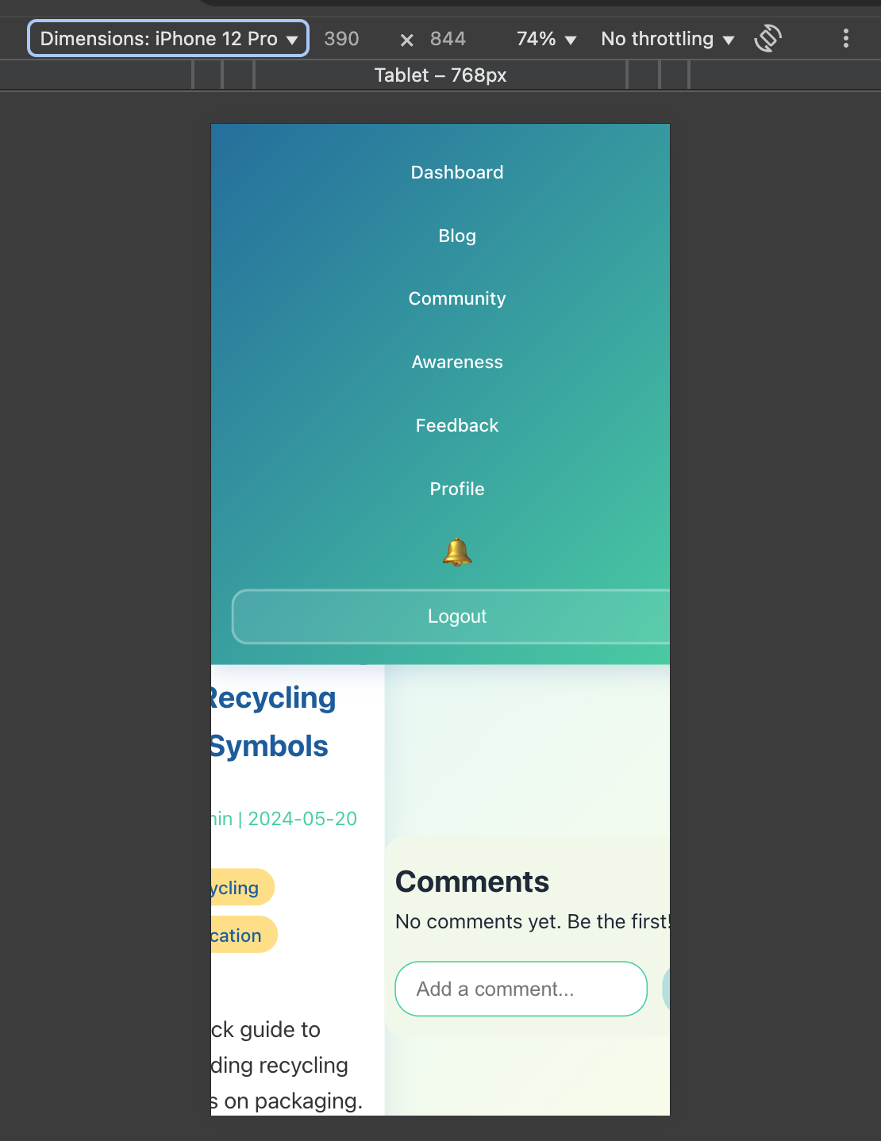

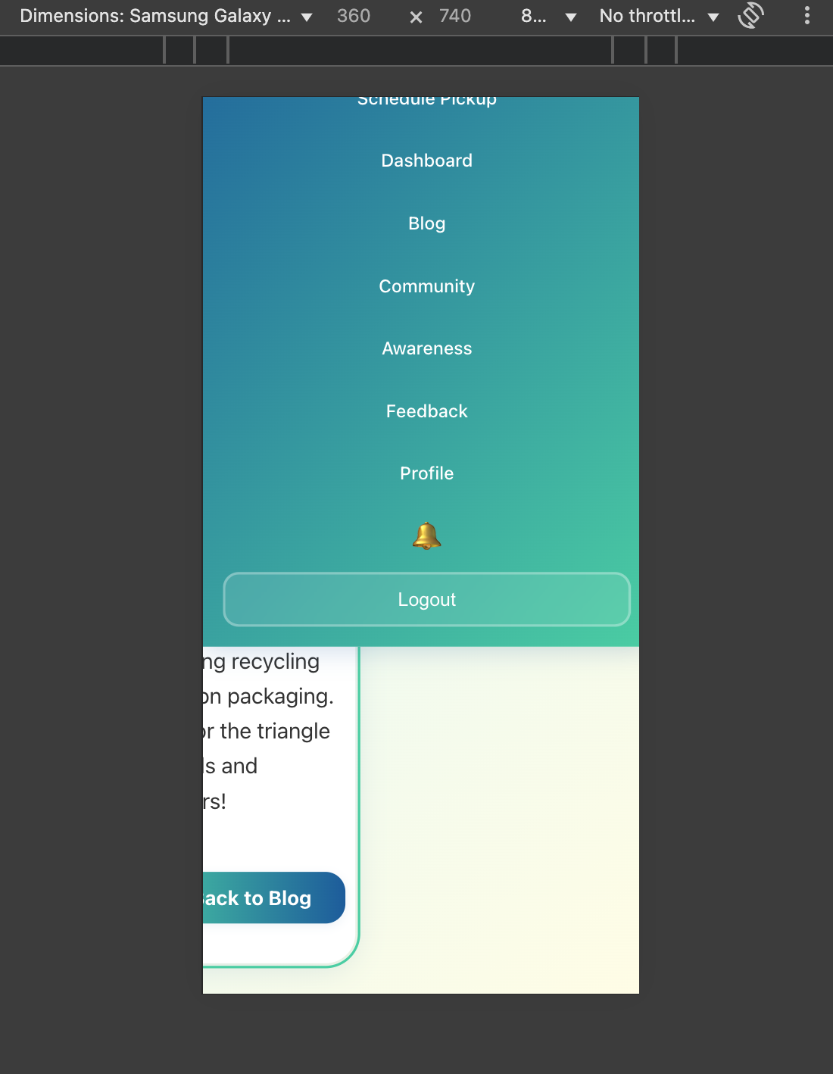

**BUG016 – Schedule Pickup Page Allows Duplicate Requests Not Reflected on Dashboard**

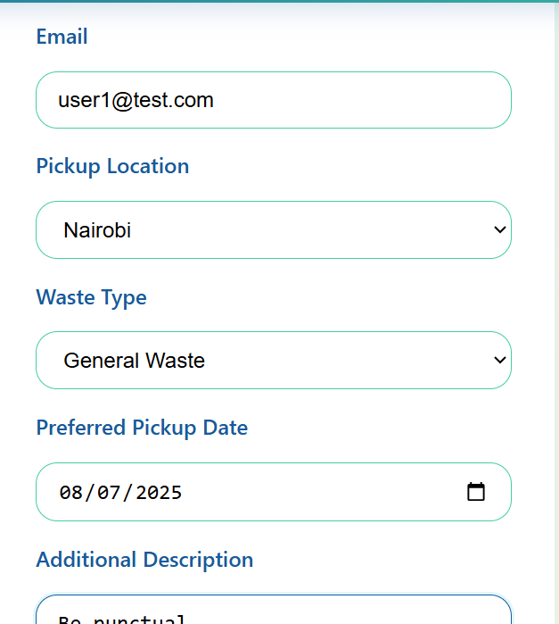

**BUG017 – Password Security Vulnerability: Accepts Weak Passwords**

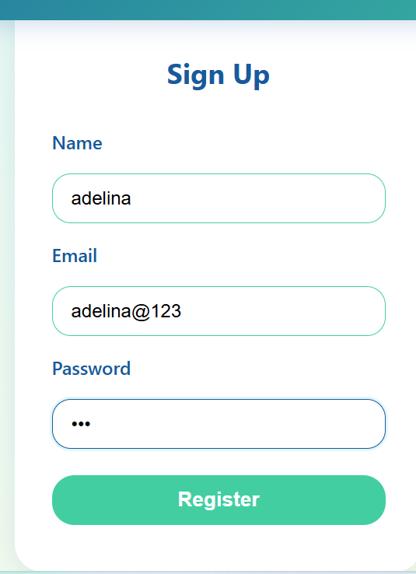

**BUG018 – Credentials Stored in Plain Text in LocalStorage**

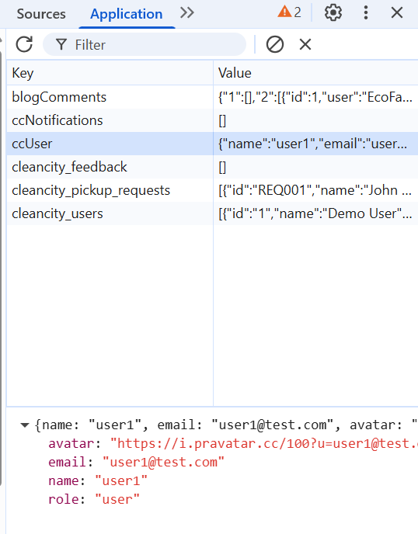

**BUG019 – Additional Description Field Accepts Over 200 Characters**

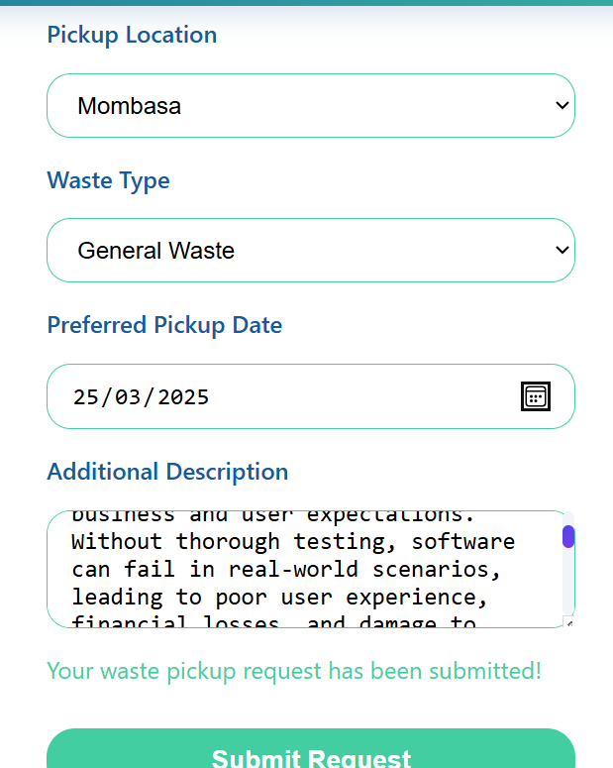

**BUG020 – No Alt Text in Awareness Page Photos**

